**Learning Activity 3-01**

**Is about:**

* Know and use the MySQLWorkbench work environment to manage databases.

**Goals:**

* View the database objects that are managed on the server.
* Interpret information from a database.
* Create and modify a database.
* Create tables in a database, add columns and set data types.
* Set primary keys.
* Establish foreign keys.
* Generate the script corresponding to the physical design of a database.

**Procedure**

1.- Start a MySQLWorkbench client connection session with the local MySQL server.

You should see that in the list of schemas or databases available on the server you have a **world database.** Select that database.

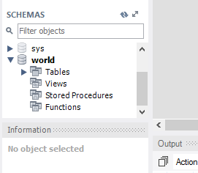

If you don't have the world database **,** you have to import it. To do this, they have the import file of that database (world.sql) in Moodle , in the activities folder of unit 03

In the schema view, under each schema or database, there is a list of the possible object types in the database (tables, views, procedures or functions). Within each object type, each element is a user-created object. As we see, in **Tables** there are three tables created:

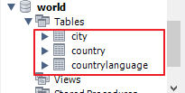

Each object has action buttons on the right to do something about the object:

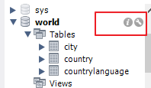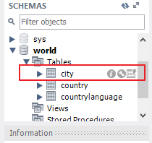

a) Access information about the World database **.** Obtain the **set of characters and collation** that the database uses, the space it occupies on disk, how many **enum type columns** it has and which columns are **primary keys** and in which tables.

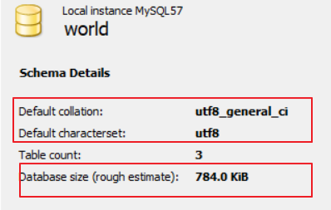

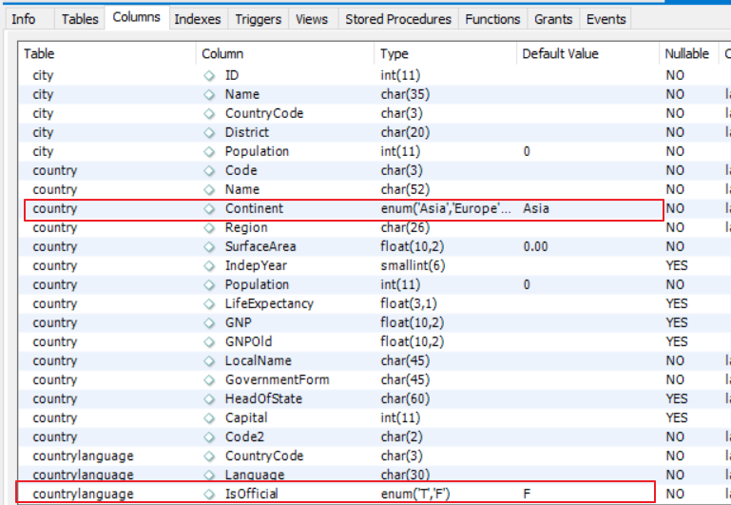

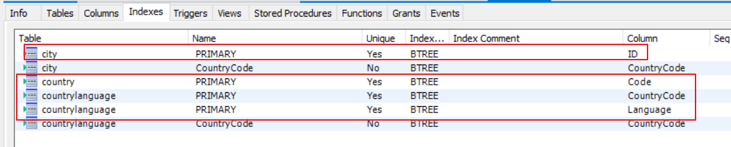

**world** database configuration and check what parameters can be configured.

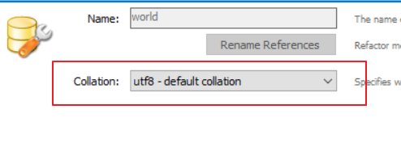

c) Access the information in the **countrylanguage table.** Get the character set and collation for the table, the storage engine, **and** for each foreign key:

* The name of the foreign key relationship.

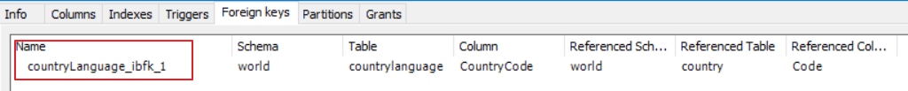

* The column or columns that make up the key.

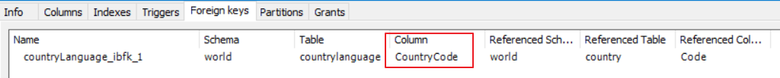

* The referenced table.

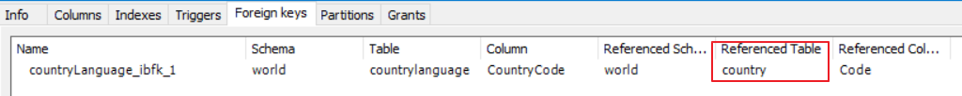

* The referenced column or columns.

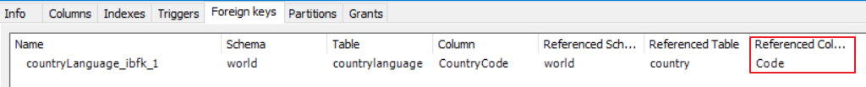

table **configuration** button you access the well-known table creation window, in this case, to allow modifying its structure.

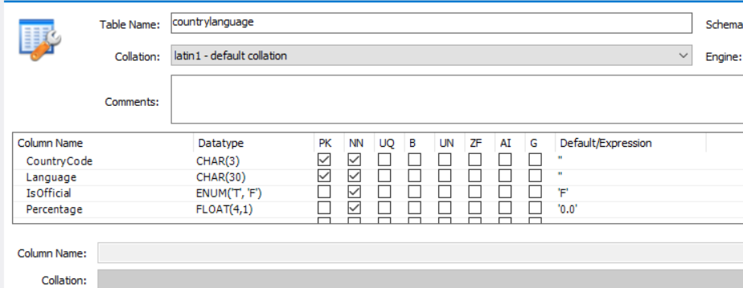

e) The table **data view button executes a query of all the columns of the table and shows us the returned result.**

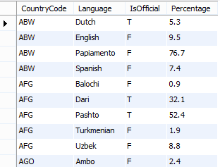

3.- Now we are going to create a MICLASE database **.**

1

**Teachers ( profid, UN ID , name)**

1

**Modules ( mod_id , mod_name, hours)**

**N**

**N**

**Taught ( FK teacher , FK module , support)**

In the toolbar, click the **Create a new schema button .**

Name the database and confirm.

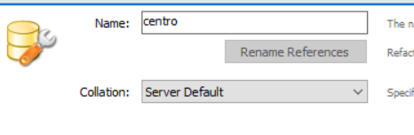

**MySQLWorkbench** sent ?

**CREATE SCHEMA `center` ;**

4.- Select or activate the myclase database **.**

Add a table . Give this table the name **teachers.** Establishes that this table has the columns **idprof (integer type, autoincrement and primary key), DNI secondary key and name.** None of the columns are nullable. Get the **SQL statement** to create the table.

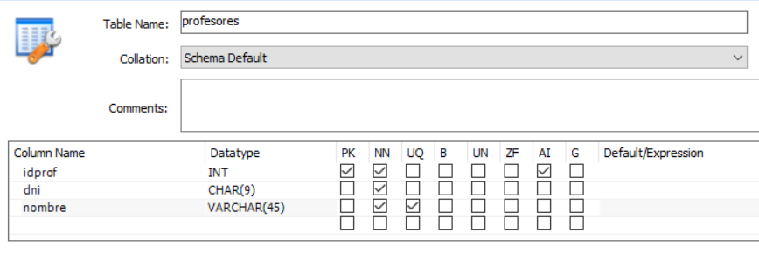

**CREATE TABLE `center`.`teachers` (**

**`idprof` INT NOT NULL AUTO_INCREMENT,**

**`dni` CHAR(9) NOT NULL,**

**`name` VARCHAR(45) NOT NULL,**

**PRIMARY KEY (`idprof`),**

**UNIQUE INDEX `UNIQUE_name` (`name` ASC));**

**modules** table with a four-character identifier for each module, the module name, and the module's weekly hours. Get the **SQL statement** to create the table.

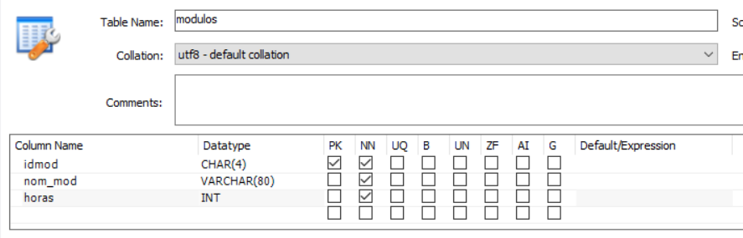

**CREATE TABLE `center`.`modules` (**

**`idmod` CHAR(4) NOT NULL ,**

**`mod_name` VARCHAR(80) NOT NULL ,**

**`hours` INT NOT NULL ,**

**PRIMARY KEY (idmod));**

**teaching** table that collects, using foreign keys, the teacher who teaches each module and a column that indicates whether the teacher is supportive. To establish the foreign key **IDProfesor** in **imparte,** you must:

* Select the **ForeignKeys tab.**
* Give the relationship a name, for example, **fk_imparte_teachers.**
* Indicate which is the referenced table ( **teachers).**
* **impartes** column is a foreign key ( **professorid).**
* Indicate the column of **teachers** referenced by the foreign key ( **idprof).**
* **Set referential integrity options or constraints**

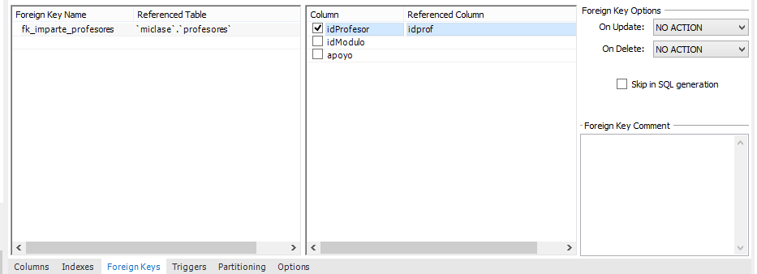

**Get the SQL statement to create the table.**

5.- Establish that the primary key in the table is Teacher+module **.**

Get the SQL statement for setting the primary key after you have created the table.

6.- Export the database to a sql script file. The file must include the instruction to create the database and must dump only the instructions to create the structure (if records had been added to the tables, the instructions to add that data would not be dumped).

